



ULTRA Int. Trade & Textile Co. Inc. Istanbul - Turkey (Production Mill.) LEBİ Fabric & Accessory Supply Co. Ltd. Istanbul - Turkey

FORLIFE Trade & Agecy Co. Ltd. Budapest – Hungary.

Establishment Products
Production Capacity Production Lead Time Factory area
Factory Location
Total Employees
Yearly Turnover

: 1980
: Sleepwear, Homewear, Outwear
: 1.0000.000 pcs/year
: 8 weeks net for production.
: 3.000 m2 (owned by Ultra).
: 5 kms from Atatürk International Airport.
: 70
: 6.000.000 EU (%100 production & exports).

Major countries of activity: Germany, England, France, Holland, Denmark, USA.

Own Brand:

Audits & Certificates:
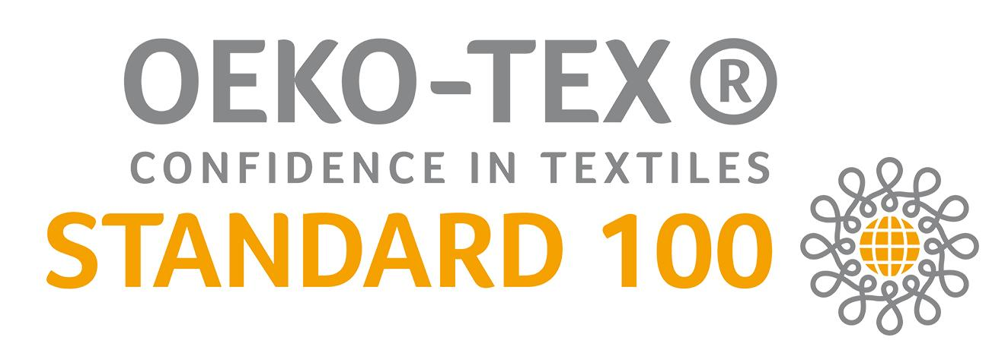



Power of Ultra:
1. A good name with an experience since 1980 in design, production & export.
2. Creates about 1000 styles per year of latest fashion. Beside young fashion lines, creates classic
lines as well. Latest collections are presented in Paris Lingerie Fairs 2 times a year.
3. Gives quick & good service having strong financial back ground.

4. Production quality is top level & prices are reasonable.

5. No minumums, can produce 500 to 10.000 pcs / style /color.
6. Different types of knitted & woven fabrics (technical or standard) and fibres are used for
production such as ribs, pointelles, terries, interlocks, jerseys, polars, poplins, voiles; cotton, organic cotton, polyester, modal, micromodal, bamboo, nylon, viscose & etc.
7. Use technics of digital prints & all kinds of placement prints, embroidery and trim aplications.

Adress : ULTRA TEKSTİL SAN. VE TİC. AŞ
İmsan San. Sitesi D Blok No:5/2
İkitelli / İstanbul / Turkey

Phones : (+90 212) 698 93 03 (pbx)

Fax : (+90 212) 698 15 17

Contacs Persons: Can ÖZOĞUZ (President) - Györgyi ÖZOĞUZ (Vice President) – Tuna ÖZOĞUZ

E-mails : can@ultratekstil.com / georgina@ultratekstil.com / tuna@ultratekstil.com

Web Site : www.ultratekstil.com

